# Adding Reports as a Springboard

**Step1:** We need to create a sandbox with tools like a Structure and Page Composer and click on Create and Enter.

**Step2:**  Once Sandbox is created go to Tools 🡪 Structure

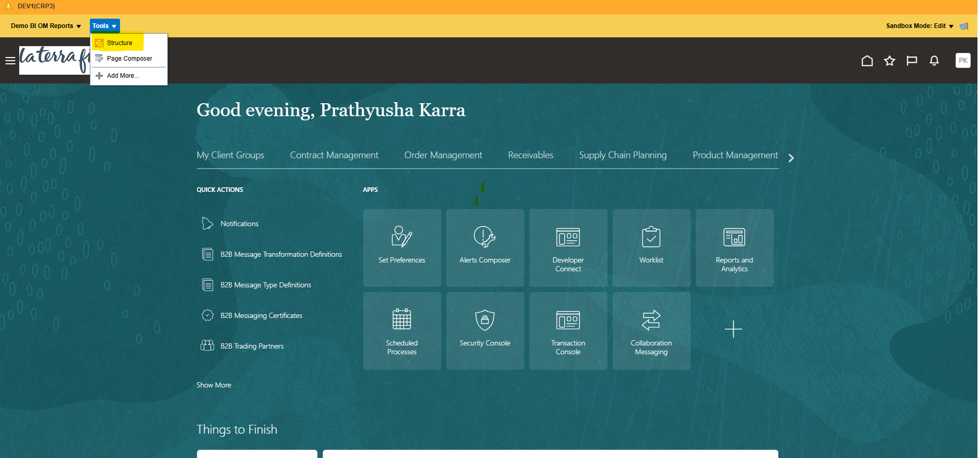

**Step3**: Create a Groupand create a Group with the required name. Save and Close

**Step4:** Now create a page entry.

Name: As the report Name

Group: The group which we created previously (under which group you want to see the tiles)

Destination: Open the report and copy the URL from the address bar.

Save and Close.

Finally, the report will be added to the group

* LTF RPT-033.Orders with BOL Summary
* LTF RPT-026 Open Orders
* LTF RPT-013 Outbound Freight Report
* LTF RPT-006.On Time and In Full Report
* LTF RPT-007.Demand Plan